DOMAIN RESISTRATION & HOSTING
Tasks

1.Search for an available domain name that could be used for a food blog similar to Zomato, and take a screenshot of the domain availability result from any popular domain registrar like GoDaddy or Namecheap.

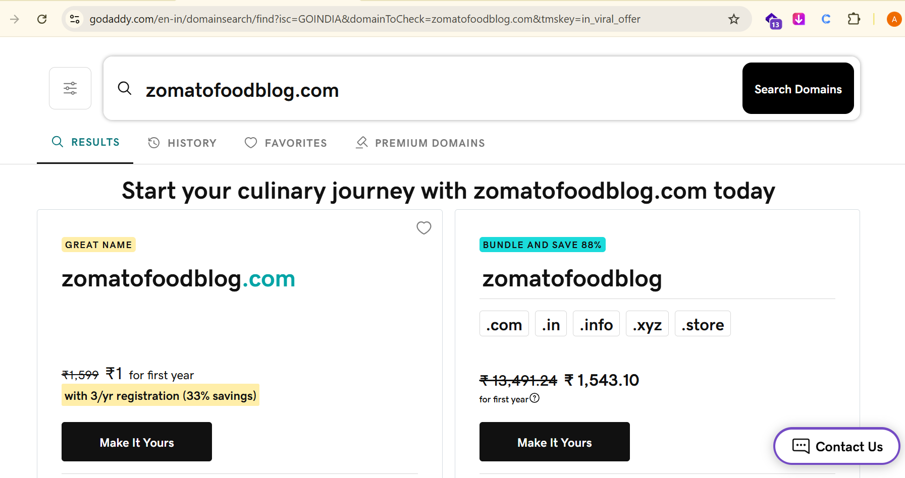

2.Compare the features and pricing of two shared hosting plans from different providers (e.g., Hostinger vs Bluehost) and create a table listing at least 5 key differences relevant for a small ecommerce website like Flipkart.

FEATURE | HOSTINGER
Price | Generally more affordable
Storage | Depends on the selected plan
Free SSL | Yes
Website Support | 24/7 customer support
Free Domain | Available with selected plans
Performance | Good performance for small websites
Best For | Beginners and small websites

3. Explain the difference between domain registration and web hosting using an analogy with Instagram usernames and photo storage, in 3-4 sentences.
=> Answer : Domain registration is like choosing an Instagram username for your website. It gives your website a unique name that people can use to find it. Web hosting is like photo storage on Instagram, where your website files, images, and content are stored. Therefore, the domain is the website’s address, while hosting provides the space where the website lives.

4.Use ChatGPT to generate a checklist of 7 steps required to launch a basic website (from domain search to going live), and paste the checklist into your assignment submission.
=> Answer :
Website Launch Checklist :
1. Choose and register a domain name.
2. Purchase or select a suitable web hosting plan.
3. Connect the domain with the hosting server.
4. Upload website files to the hosting account.
5. Install and configure SSL (HTTPS).
6. Test the website on desktop and mobile devices.
7. Publish the website and check that all pages and links work correctly.

